THREAPWOOD PARISH COUNCIL

Annual Report May 2016

CHAIRMAN'S REPORT - 2016
During 2015 -2016 the Parish Council (PC) has continued its business, making decisions on behalf of the community and listening to concerns and ideas. Bye and large the year has seen a settled and quiet period, building upon past initiatives, such as monitoring the effectiveness of the Speed Limit and reinforcing pedestrian links between Upper and Lower Threapwood. Nevertheless, there has been some change.

- Our temporary Parish Clerk (Richard Salmon) has decided to join us on a permanent basis.
- One new Parish Councillors has been co-opted onto the PC, Helen Groves.
- The PC Website has been re-established and a new Facebook Site introduced
- The PC agreed to start a process to achieve Quality Status.

In 2015 -16, Cheshire West and Chester have continued to take into account the Parish Council's comments and responses on behalf of their parishioners. These include:-

- Planning Matters We have received the following application in Threapwood in the past 12 months:

The Hollies Back Lane(Loop Road) Threapwood Malpas Cheshire SY14 7AT
Single storey extension, garage, front and rear dormer windows and internal alterations. The Hollies, off Back Lane - single storey extension. This was approved in March 2016 for garage single storey extension bay windows and alteration to interior. This is the only planning application which was received in the parish in the currency of the past 12 months.
Decisions:
In addition to the approved decision of the application above, there was an additional application carrying over from the previous year and this was approved in November 2015 as follows:
The Hollies Back Lane (loop Road) Threapwood Malpas Cheshire SY14 7AT
This decision relates to the same property address as the above application, but was for a separate matter. The application read:
“Conversion of Agricultural Building with link to Former Cottage to Create a Single Dwelling, Erection of a Two Bay Open Fronted Garage and Conversion of Milking Parlour to Create an Annex”
This essentially was to bring a former cottage back into residential use together with the extension into a former agricultural building by a link to create satisfactory modern day size of accommodation.
This was approved on Monday 23rd November 2015

- Speed Limits Review. Following complaints by residents about speeding traffic, the Parish Council has requested the Police visit Threapwood with their speed monitoring equipment. They have attended on several occasions and have checked the speed of traffic in different locations within Threapwood

- Threapwood Parish Council Website. The Parish Councils website at http://www.threapwoodparishcouncil.gov.uk/ is where you can find details of the councils Accounts, Minutes, Planning Register and other information.

On the councils Facebook page https://www.facebook.com/pages/Threapwood-Parish-Council/521759271296988 you have an opportunity to interrelate with the council and others.

- The Audit, Annually the parish council has to submit its accounts and other details for audit, the auditors must satisfy themselves that the accounts are prepared in accordance with statute and regulations and that proper accounting practice have been observed. All parish councils now have to publish their accounts and other information such as Agendas and Minutes, on a website in accordance with the Transparency Code for Smaller Authorities.

- The Precept. The Precept is the Parish Councils share of the Council Tax. The Precept demand goes to Cheshire West Council who then collect the tax on our behalf. For the year 2015-6 the Parish Council held the precept at £2000, this equates to a band D charge of £13.89 in that year.

- Quality. At the January Parish Council meeting, Council resolved to seek Quality Award status which would demonstrate that the Parish Council meets a minimum requirement for operating lawfully and according to standard practice and demonstrates that the council achieves good practice in governance, community engagement and council improvement. It is expected that the process of qualifying will be complete before the yearend.
Steve Chewins
Chairman

Threapwood Parish Council Councillors

Cllr Carol Bennion
The White Cottage
Threapwood
Malpas
SY14 7AL

Cllr Helen Groves  Smithy Filling Station  Threapwood  Malpas  SY14 7AL | 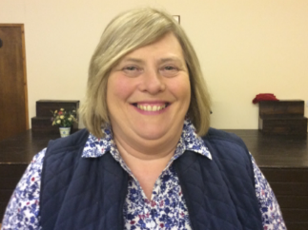
Cllr Betty Young  The Rosary  Greaves Lane  Threapwood  Malpas  SY14 7AR | 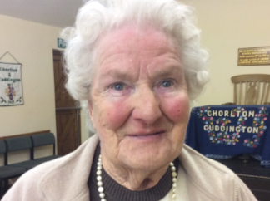
Chairman
Cllr Steven Chewins
Mount Pleasant
Greaves Lane
Threapwood
Malpas
SY14 7AR
Steve.Chewins@ramboll.co.uk

Cllr Stephen Ford  Rock Villa  Sarn  Malpas  SY14 7LN | 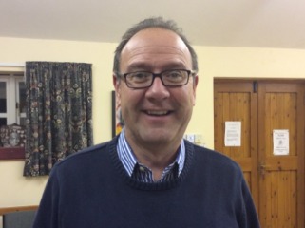
Cllr Brian Holmes  Horseshoe Cottage  Oldcastle Lane  Threapwood  Malpas  SY14 7BA | 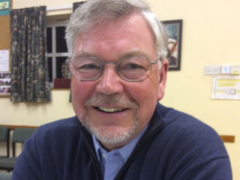
Vice Chairman
Cllr Miles Lewis
Holyland
Threapwood
Malpas
SY14 7AL
Clerk
Richard Salmon
8 Market Place
Hampton
Malpas
SY14 8HS
richard@offroading.net
0780 3129 477

Threapwood Parish Council Meeting Dates
DATES OF FUTURE MEETINGS all at Chorlton WI Hall subject to availability
July 27th 2016 | September 28th. 2016
November 30th 2016 | January 25th 2017
March 29th 2017 | May 31st 2017. Parish & Parish Council
Meeting are held on the last Wednesday in the odd month at 7.30 pm. and are advertised on the notice boards at least 3 clear days before the meeting. Extraordinary meetings are called as required.

Threapwood Parish Council Accounting statements 2015/16

 |  | 31/3/14 | 31/3/15 | 31/3/16
1 | Balance b/f | 2282.08 | 3751.23 | 5962.17
2 | Precept (+) | 2000.00 | 2000.00 | 2000.00
3 | Other receipts (+) | 1483.85 | 1548.94 | 2533.27
4 | Staff costs (-) | 1000.00 | 800.00 | 1425.78
5 | Loan (-) | Nil | Nil | Nil
6 | Total other costs (-) | 694.50 | 538.00 | 2373.73
7 | Balances c/f = | 3751.23 | 5962.17 | 6695.93
8 | Total cash | 3751.23 | 5962.17 | 6695.93
9 | Total fixed assets | 6233.00 | 6233.00 | 6233.00

http://www.threapwoodparishcouncil.gov.uk/

https://www.facebook.com/pages/Threapwood-Parish-Council/

